VETERINARY OPIOID  EDUCATION IN INDIANA  WHAT YOU NEED TO KNOW  In January of 2018, the IVMA Board of Directors approved assembling the Veterinary Opioid Education Task Force. This task force is charged with assessing the laws that pertain to the legal prescribing and dispensing of opioid drugs by veterinarians in Indiana. The task force has been busy this year compiling the best and most accurate information for IVMA members. This work by IVMA illustrates one more important value of your membership.  The information below describes these changes:  1. Registration for the INSPECT database: IC  35-48-7-11.3o Beginning January 1, 2019, a practitioner who is permitted to distribute, dispense, prescribe, conduct research with respect to, or administer ephedrine, Pseudoephedrine, or a controlled substance in the course of the practitioner’s professional practice or research in the United States must be certified under section 11.1(d)(4) of this chapter to receive information from the INSPECT program. (This applies to Veterinarians who hold an Indiana CSR.) INSPECT (Indiana Scheduled Prescription Electronic Collection and Tracking Program) is Indiana’s own prescription drug monitoring program (PDMP) that serves as a tool to reduce the abuse, acquisition and diversion of prescription drugs in Indiana.  Essentially, INSPECT is an on-line controlled substance database that attempts to:  • Maintain an available warehouse of patient information for health care professionals  • Provide an important investigative tool for law enforcement  INSPECT is designed to help identify patients (or in the case of veterinarians, the owners of veterinary patients), who are addicted to opioids and engage in something called “doctor shopping” in which they go from doctor to doctor, or pharmacy to pharmacy to obtain as many prescriptions of opioids as possible.  Veterinarians using this tool can contribute to reducing the impact of the opioid abuse crisis in their communities. ACTION: Become familiar with, and sign up for, participation in the INSPECT program: https://www.in.gov/pla/inspect/ This must be completed by January 1, 2019.  BEST PRACTICE FOR USING INSPECT: It is important to limit queries for potential opioid solicitation by an animal owner to only those animals currently under your medical care. There are potentially criminal and civil liabilities for INSPECT queries made on animal owners or individuals that are outside of your professional responsibilities.  If you choose to delegate an individual to assist you with running your INSPECT reports and register them as a delegate account holder for that purpose, please advise them of the limits on the scope of INSPECT queries since the veterinarian linked with the INSPECT account is responsible and legally liable for ALL activities made using their account. | 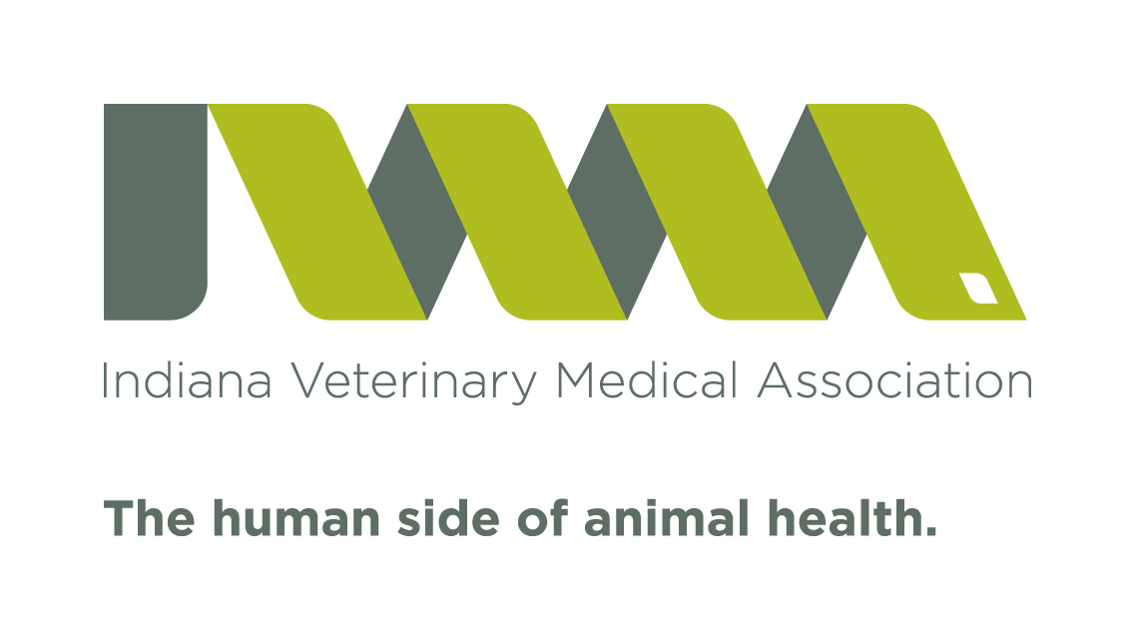  Ivma  317-974-0888  Fax 317-974-0985  www.invma.org  lisa@invma.org  ACTION: Become familiar with, and sign up for, participation in the INSPECT program: https://www.in.gov/pla/inspect/ This must be completed by January 1, 2019  If you choose to delegate an individual to assist you with running your INSPECT reports and register them as a delegate account holder for that purpose, please advise them of the limits on the scope of INSPECT queries since the veterinarian linked with the INSPECT account is responsible and legally liable for ALL activities made using their account.  Mandatory query of the INSPECT  Beginning January 1, 2021, all practitioners. THIS TIMEFRAME APPLIES TO VETERINARIANS.  Continuing education on opioid prescribing and potential abuse will be required to renew your CSR by October 15, 2019  The taskforce is currently working to develop the best options for IVMA members to obtain this continuing education.

2. Continuing education on opioid prescribing and potential abuse will be required to renew your CSR by October 15, 2019 According to Senate Enrolled Act 225, all practitioners who renew their CSR must complete two (2) hours of continuing education during the previous two years addressing the topic of opioid prescribing and opioid abuse. The task force is currently working to develop the best options for IVMA members to obtain this continuing education.

3. Mandatory query of the INSPECT database will be required of those prescribers in certain instances: IC 35-48.7-11.1o Beginning July 1, 2018, a practitioner who has had the information from the database integrated into the patient’s electronic health records.
- Beginning January 1, 2019, a practitioner who provides services to the patient in the emergency department of a hospital licensed under IC 16-21 or a pain management clinic.
- Beginning January 1, 2020, a practitioner who provides services to the patient in a hospital licensed under IC 16-21.
- Beginning January 1, 2021, all practitioners. THIS TIMEFRAME APPLIES TO VETERINARIANS.

More information from the task force will be forthcoming to assist IVMA members with how to comply with these new changes in Indiana law.
To register for the PDMP and to perform patient look-up requests please use the following link: https://indiana.pmpaware.net/login/
Prescription data submissions now being submitted through the Appriss Clearinghouse. Please use the following link: https://pmpclearinghouse.net
If you had an account on the original Indiana Prescription Monitoring Program system, please check your email for information regarding access to the new website.
If you are unable to locate the email or if you require technical assistance please contact support at 844-446-4767 or submit your request to inspect@pla.in.gov and someone will assist with account updates and password resets within 24 hours.

